Empowering Respectful Learners

S1 into S2/3
Course Choice Information

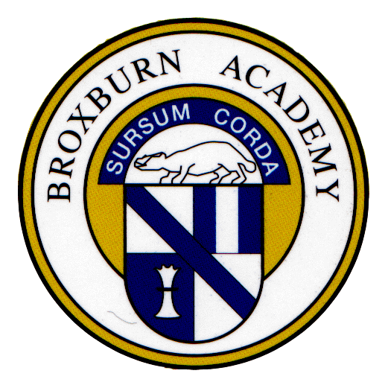

February 2020

We have made this leaflet for first year pupils and their parents/carers. We hope that it gives you the right amount of information about S2 courses. You will see the courses on offer in the final column of the choice sheet. This leaflet might help with any discussions that you have with your child. Our aim is that your child makes the best choices for them.

In S2, all pupils will study:
- English
- maths
- modern languages
- science
- social subjects
- personal and social education [PSE]
- religious, moral and philosophical Studies [RMPS]
- physical education [PE]

Pupils make three choices from the last column on the choice sheet. They will study these subjects for the next two years.

At the end of S3, pupils will choose which 5 subjects to continue to study towards a national qualification. All pupils do English and maths. You will get more information about this in future.

Before making choices pupils should discuss all the possibilities with parents, relatives and friends. Use the parents’ night to speak to staff about their decisions.

Our aim is that your child makes the best choices. It is important pupils do their very best at Broxburn Academy.

When choosing, think about these dos and don’ts:

DO read this leaflet carefully. As you do so, pay particular attention to subjects that interest you.

DO choose subjects where you think you will do well. An interest in a subject and the willingness to work hard are important.

DO talk to your teachers and parents about your choices.

DO think about the kind of job you would like. Your guidance teacher and/or the careers adviser will help.

DO think carefully about your choices. It is not easy to make changes later on.

DON'T choose a subject just because a friend has. It's YOUR future. In any case, your friend may not be in the same class as you, even if you do choose the same subject.

DON'T choose a subject just because you like the teacher. Teachers don’t always continue with the same class.

DO remember that all subjects are open to both boys and girls. Women enter careers in engineering and industry. Men enter creative and caring occupations.

Art and Design

The Art & Design course uses knowledge and understanding with practical art experiences. The focus is on design. Pupils learn about the work of artists and designers. There is scope for personalisation and choice. The course has three parts: design, expressive drawing/painting and critical activity. We have designed the course to give a broad range of skills and experience.

Business Education

Employers want young people to have a knowledge of the business world. We rely on businesses and entrepreneurs to create wealth and jobs in our society. This course helps to create better informed employees and business owners. Pupils continue to develop more advanced skills in office software packages. These include databases, spreadsheets, and word processing. These are essential skills for any employee/employer.

Drama

The Drama Course provides chances for pupils to develop skills in creating and presenting drama. It focuses on acting, characterisation and devising. New skills include the technical aide, such as lighting and sound. Pupils develop their ability to appreciate and evaluate drama.

The course is suitable for those who want a career in theatre. It is for pupils who want to develop core skills in communication, working with others and problem solving.

Hospitality

This course will develop a range of cookery skills and processes. It includes food preparation techniques. Learners will develop an understanding of ingredients. This includes where they come from and what they are for. We look at sustainability of ingredients. We look at the impact of ingredients on health and wellbeing. We learn food safety and hygiene skills.

Music

Pupils will work at 3rd and 4th level in music. This is part of a broad view of expressive arts. Pupils will study:
- PRESENTING –performing on an instrument/voice of their choice either alone or in a group.
- CREATING – composing music and using technology.
- EVALUATING – listening to a variety of music. They will analyse technical aspects and express personal opinions.

PE Aesthetic

We aim to develop a range of movement skills in challenging contexts. Learners use strategies to make decisions to improve performance, and then apply this knowledge to their own performance. This is in a range of activities which include dance, gymnastics, badminton, swimming and fitness. Pupils should NOT choose PE Aesthetic in both columns H and K.

Uniformed Services

We aim to talk about the roles and responsibilities of uniformed and emergency services team members. We explore the career opportunities in the uniformed and emergency services.

Learners take part in practical activities. These develop knowledge and understanding of uniformed and emergency services environments. We talk about generic employability skills. We focus on specific employability skills in the uniformed and emergency services. These include timekeeping, attendance and the ability to follow instructions. Pupils develop reflecting and evaluating. Pupils review their own skills and record their progress.

